

**SUMMER INTERNSHIP PROJECT** **REPORT**

“Sales Analysis of Different Health & Hygiene Categories of ITC in new set of outlets”

**A Summer Internship Project Report**

**Submitted for the partial fulfilment of the Post Graduate Diploma in Management in Marketing**

**Session 2019-2021**

**Submitted By: Submitted To:**

SAIKAT DUTTA

PGDM 3rd sem

Roll No-13

Registration No- 12019008012013

Under the guidance of

SAIRIK MUKHERJEE

 Prof. ANIK KIUMAR HAZRA

Department of

For the Academic Year

Institute of Engineering & Management

**Y-12, Salt Lake, Sector-V, Kolkata-700091**

**Table of Contents**

**S.No. PARTICLUAR PAGE No.**

1. TRAINING CERTIFICATE
2. PREFACE
3. ACKNOWLEDGEMENT
4. DECLARATION
5. Introduction
6. InDUSTRY OVERVIEW
7. LITERATURE REVIEW
8. CHAPTERISATION
9. Company Profile-ITC
10. History of the Company
11. The ITC Way
12. Company Vision
13. Company Mission
14. Core Values
15. ITC’s business portfolio
16. FMCG
17. Hotels
18. Paperboard & Packaging
19. Agriculture
20. Information Technology
21. Awards & Accolades over the years
22. Governance Structure of ITC
23. Board of Directors
24. Distribution Network of ITC Ltd.
25. An Overview of Projects
26. Market Research
27. Research Objectives
28. Methodology
29. Data Analysis
30. Observations and Findings
31. Suggestions
32. Product Research
33. Research Objectives
34. Questionnaire Asked
35. Methodology
36. Concerned Product
37. Research Process
38. Research Design
39. Data Analysis
40. Consumer’s Voice
41. Product Life Cycle
42. SWOT Analysis
43. BCG Matrix
44. Recommendations
45. Conclusion
46. Limitations
47. Bibliography
48. Appendices



**CERTIFICATE**

**TO WHOM IT MAY CONCERN**

This is to certify that the project report entitled “***Sales Analysis of Different Health & Hygiene Categories of ITC in new set of outlets***”, submitted by **SAIKAT DUTTA (*Registration No.* 12019008012013 *of PGDM, Roll no.- 13)***, of **INSTITUTE OF ENGINEERING &MANAGEMENT,** in partial fulfilment of requirements for the award of the degree of **Post Graduation Diploma in Management in Marketing,** is a Bonafede work carried out under the supervision and guidance of **Prof. Anik Kumar Hazra** during the academic session of 2019-2021. The content of this report has not been submitted to any other University or Institute for the award of any other degree.

It is further certified that work is entirely original and its performance has been found to be quite satisfactory.  
  
  
  
  
_________________________ ____________________________

Prof. Anik Kumar Hazra Prof. Dr. Sujit Dutta

Project Guide H.O. D

Dept. of …………. Dept. Of Management

Institute of Engineering & Management Institute of Engineering &Management

Principal – Management

Institute of Engineering & Management

Sector-V, Salt Lake Electronics Complex, Kolkata-700091

 **PREFACE**

Project undertaken by me helped me to gain good practical knowledge in the concerned field. This project entitled “Sales Analysis of Different Health & Hygiene Categories of ITC in new set of outlets” helped me to have a better understanding of new opportunities of health & hygiene products in new set of outlets.

Iwish that the experience and learning I gained from this project would help me to enhance my professional career in future.



**ACKNOWLEDGEMENT**

This is to acknowledge my sincere thanks and gratitude to all those concerned and who have contributed in this project.

To begin with, I wish to acknowledge and express my gratitude to **Mrs. Farheen Kazi, HR Manager** who gave me the opportunity to work in this organization.

A mammoth project of this nature calls for intellectual nourishment, professional help, and encouragement from many quarters. Doing summer internship from the esteemed organization ITC, Kolkata has given me a chance to apply all theoretical inputs to real-life situations. Overall, it was an entirely a learning experience for me.

I am grateful to my project In-charge **Mr. Sairik Mukherjee (Assistant Branch Manager, GR2, ITC Kolkata)** for his continuous assistance and inspiration. The knowledge, advice, support, suggestion, helpful tips given to me by him helped me to successfully complete this project.

I am also thankful to **Mr. Sumit Nag (Area Executive, GR2, ITC Kolkata), Mr. Ashish Banerjee (Area Executive, ITC Kolkata), Rana Sengupta (Team Leader), Ram Dutta (WD)** and the staff members of ITC for giving me the useful information whenever I approached them.

I am sincerely feeling indebted to **­­­­­­­­­­­­­­­­­­­­­­­­­­­Prof. Anik Kumar Hazra (IEM Faculty)** for his valuable suggestion and inspiration to undergo this study and his unstilted help which he gave for the completion of this project.

I would also like to express our sincere gratitude to Prof. Dr. Satyajit Chakrabarti (Director, IEM), Prof. ……………. (Principal-Management, IEM) and Prof. Dr. Sujit Dutta, HOD of (Management) and other faculties of Institute of Engineering & Management, for their assistance and encouragement.

At last, I am deeply grateful to **my** **family, mentor, faculties and friends** who have given every help and moral support and their constant advice, which enabled me to pursue my project.

**Name of the Student**

Reg. No:

Dept. of Management

Institute of Engineering & Management, Kolkata



**Declaration**

I hereby declare that this project report has been personally made by me. This information given is correct and the matter has not been copied from any report. In case of any discrepancy or false information found in this report, I will be personally responsible for it.

**SAIKAT DUTTA**

**PGDM 3rd sem**



**INTRODUCTION**

The Indian FMCG sector is the fourth largest sector of the Indian economy. The FMCG industry is more than 115 years old. Consumable items (other than groceries/pulses) that one needs to buy at regular intervals. These are items which are used daily, and so have a quick rate of consumption, and a high return. FMCG can broadly be categorized into three segments which are **Household items as soaps, detergents, household accessories, etc, Secondly Personal care items as shampoos, toothpaste, shaving products, etc and finally. Thirdly Food and Beverages as snacks, processed foods, tea, coffee, edible oils, soft drinks etc.**

India’s fast-moving consumer goods (FMCG) sector is on a roll. Riding on the back of increasing demand and changing consumer preferences – thanks to higher disposable incomes and the retail revolution – the sector has been posting double-digit growth over the past couple of years. The sector has seen the emergence of new product categories and products that seek to fulfil the increasing aspirations of a new generation of Indians, who are turning out to be very demanding consumers. Besides, FMCG products fulfil the primary needs of consumers and are usually small-ticket items that are necessary for most households. “**The FMCG sector would continue to do well not only because it is a defensive and well entrenched one, but also because it logs directly on to the fundamental economic growth potential of the country**,” explains Milind Sarwate, chief, human resources and strategy, Marico Ltd, makers of hair care, skin care, edible oils and fabric care products. “As income levels continue to grow (although now at six to seven per cent and not eight to nine per cent as earlier) more people are likely to shift to consumption of branded products and services. Hence, the growth trend is likely to continue.”

The competitiveness of ITC’s diverse businesses rest on the strong foundations of institutional strengths derived from its deep consumer insights, cutting-edge Research & Development, differentiated product development capacity, brand-building capability, world-class manufacturing infrastructure, extensive rural linkages, efficient trade marketing and distribution network and dedicated human resources. ITC’s ability to leverage internal synergies residing across its diverse businesses lends a unique source of competitive advantage to its products and services.

Today ITC is the country’s leading FMGC marketer, the clean market leader in the Indian paperboard and Packaging industry, a globally acknowledged pioneer in farmer empowerment through its wide-reaching Agri- Business, the second largest Hotel Chain in India and a trailblazer in ‘green hoteliering’. ITC InfoTech, a wholly-owned subsidiary, is one of India’s fast-growing IT companies in the mid-tier segment. This portfolio of rapidly growing businesses considerably enhances ITC’s capacity to generate value for the Indian economy.



**INDUSTRY OVERVIEW**

The stocks of domestic fast-moving consumer goods (FMCG) companies are struggling on Dalal Street compared to its foreign peers, as demand slowdown has gripped rural and urban markets. While shares of top five foreign promoter-owned FMCG companies jumped 18.9 per cent, on an average, so far this year, the top five domestic FMCG players logged negative returns. 

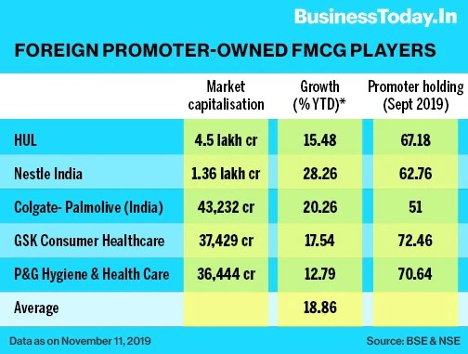The five subsidiaries of the foreign multinational companies – Hindustan Unilever (HUL), Nestle India, Colgate-Palmolive (India), Procter & Gamble Hygiene & Health Care and GlaxoSmithKline Consumer Healthcare – have recorded gains in the range of 13 per cent to 28 per cent year-to-date. By comparison, the Sensex spiked 11.22 per cent during the same period. HUL is the most valued FMCG company in the stock market at Rs 4.5 lakh crore, while the second biggest player ITC is Rs 1.3 lakh crore behind at Rs 3.2 lakh crore.

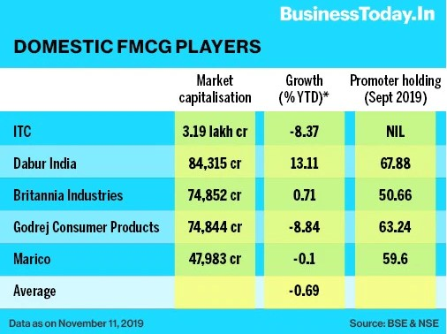

Among the ten FMCG companies evaluated, Nestle is the top performer that increased its market value by 28.3 per cent to Rs 1.36 lakh crore so far in 2019. Dabur India, the top domestic FMCG player, grew its market cap by 13.11 per cent to Rs 84,315 crore. The stocks of ITC and Godrej Consumer Products (GCPL) fell the most by 8 per cent and 9 per cent, respectively. The two other Indian companies – Britannia and Marico – registered almost muted growth.



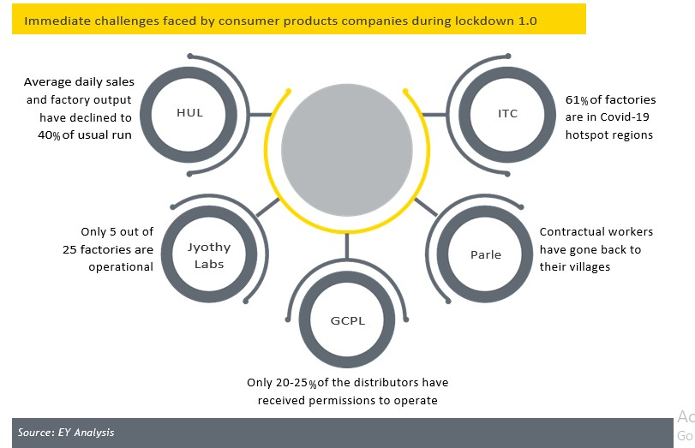The COVID-19 pandemic continues to impact most industries at an unprecedented scale globally, including consumer products (CP) that has witnessed significant disruption over the past few months. Amidst widespread health concerns, travel restrictions and local movement limitations, several companies in India are already feeling the heat.

The crisis is impacting some categories more than others. Essentials (staples, packaged food, home and hygiene products) are less impacted, while economic concerns have reduced spending on discretionary goods like confectionery and appliances.

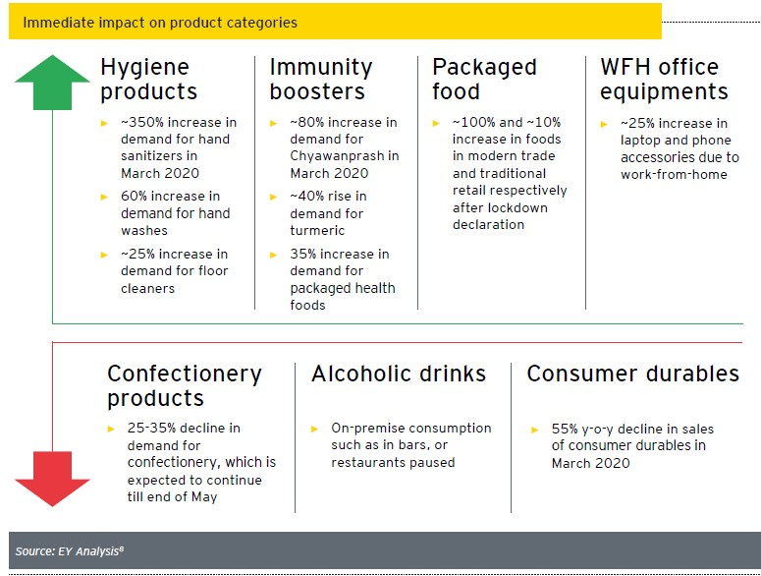Indian FMCG companies face a multitude of challenges “**now**”, “**next**”, and “**beyond**”. We are currently in the “now” phase where most companies are facing a host of challenges such as labour shortages in factories, unoptimized production, restrictions in vehicle movement and inability to ensure essential products are available to consumers. In the medium term, or the “next” phase, where the government starts easing restrictions, companies will need to focus on bouncing back from the current situation. The pandemic will most likely follow a see-saw pattern of recovery and hence, companies must build an agile operating model to minimize future disruptions in the “next” phase. In the long-term “beyond” phase, they need to focus on transforming to succeed in a new business landscape.

To address the crisis head-on and ensure business continuity, companies must devise strategies for the “now”, “next” and “beyond”. The change will be multifaceted - from building permanent safety measure in office and on shop floors to gaining greater control over end-to- end distribution network. Companies must proactively anticipate and be ready to respond to new habits that consumers will develop after living through the crisis.

There will be increased focus on health and wellbeing and higher demand for value brands as consumers trade down. Hence, re-evaluating brand portfolio to win back consumers would entail re-adjusting pack sizes and pricing to re-define value proposition as well as taking an opportunistic stance by developing “categories of tomorrow” (such as, hand sanitizers, disinfectants, immunity boosters).



Despite the ongoing challenges, increased demand for hand sanitizers has led to category expansion and attracted 150+ new players in less than a month’s time. Similarly, new entrants have been capitalizing on growing demand for packaged foods.

**How companies are coping with immediate challenges**



**Britannia**



**GCPL**



**Dabur**

Plan to write-off the value of surplus inventory of its bottling partners

Launched “Break the chain” a nationwide multimedia campaign to empower the general public with virus prevention strategies

Partnered with NGOs to distribute essential groceries to the needy

Launches “innovative 2 Beat Covid” challenge, inviting solutions for low-cost ventilators and PPE

Exploring adjacencies with focus on staples, essentials, health & hygiene categories

Changed the practice of two drivers per truck to one driver per truck, thereby reducing the need of 50% truckers

Partnered with DUNZO, an online delivery platform for contact less delivery for essentials

Launched “Dabur Aashray” insurance scheme for its frontline staff



**Nestle India**



**HUL**



**Coca-Cola India**



**Marico**



**ITC**



**Tata Consumer**

Allowing employees to work-from-home

Every business crisis disrupts normality and pushes companies out of their comfort zone; it also offers opportunities to reinvent business models to make them fitter for the new world. While preparing for the resilience strategies, companies need to take hard look at their operations to cull out inefficiencies and reorient the business to drive future growth.

**LITERATURE REVIEW**

**Gaining Supply Chain Advantage in Emerging Markets**

**(Solving Efeso white paper, written by: Mr. Clive Geldard, Group Vice President, Retail and Supply Chain)**

This white paper was published by VP of Solving Efeso group which is top management consulting group operating in more than 50 nations across the world. This white paper throws light on the following aspects:

**Triple A-rated supply chain- affordable, available, appealing**

**“One size fit one” against “One size fit all”**

**Grow your own talent and close the skill-gap**

**Buy in or settle in**

**Supply everybody, everywhere**

The author also lays stress on the fact that how important are emerging markets for the companies in current economic scenario. He suggested that any for any to grow emerging markets such as those of BRIC countries are an area of immediate focus and cannot be neglected. He also cites the following facts:

**Around 77% of Asia’s population resides in only two countries China and India**

**Big FMCG players like Coca Cola, Unilever, Danone and Pepsi Co are currently earning more than 20% of their revenue from the latest emerging markets**

**FMCG Distribution Channels in India: Challenges and Opportunities for Manufacturers and Retailers**

**(Published in Journal of Global Business Issues, 2008 Written by – Debi P Mishra, University of New York)**

**This article explores strategic role of distribution channels in FMCG sector. It also Comment upon state of current distribution channels in India and the issues relevant in the current scenario. It identifies four archetypes that FMCG firms can use based upon axis of access and per capita demand. It basically classifies markets into 4 types:**

A1 i.e. Urban markets: These markets have a High per capita demand of goods and have an easy market access

A2 i.e. Emerging markets: These markets have a Low per capita demand of goods and have an easy market access

A3 i.e. Oasis markets: These markets have a High per capita demand of goods and have a difficult access to market. These markets have huge potential because of high per capita demand. These markets are the future Urban markets in the making

B i.e. BOP: These are the bottom of the pyramid markets and have a Low per capita demand of goods and have a difficult access to market. These markets will not provide immediate profits but are vital considering the long-term impact of any strategy.

**Md. Abbas Ali1, Venkat Ram Raj Thumiki2 and Naseer Khan1 (2012) states that** Companies marketing FMCG to ru­ral consumers cannot merely extend their general marketing strategies to rural markets. Instead, they need to devise rural specific strategies. In this process, they need to understand crucial issues relating to rural consumer behaviour and more specifically relating to different geographic regions of the coun­try. This paper focuses on understanding factors that affect the rural purchase of FMCG in South India.



**Mohammad Ali Daud (2013)**, explore in his study even if rural consumers do have the aggregate monthly income to purchase branded products, they tend not to have enough money at one point of time to actually make the purchase of an item. This is why in areas where brand­ed products are available, they are often sold in loose quanti­ties since they fall into the purchasable range.

**Anupam Jain and Meenakshi Sharma (2012) revealed** that brand awareness in rural areas particularly in respect of beauty care possible due to continuous and steady improvement in consumer and health care products is showing an increasing tendency. People are not worried about the price of the product. They are showing willingness to spend higher price when they realize that they can afford to spend. Since the usage of branded products of re­puted companies will elevate their status as well as stature in that village. Brand quality, Price, Easy availability, Family liking, advertisement, variety and credit attributes have been taken as variables for the measurement of Brand perception in the study.

**Kavitha T. C. (2012), revealed in her study,** the new phase of rural consumption appears to provide a great opportunity for the FMCG sectors. Marketers will need to evolve new strategies to connect and communicate with a more aware and unreserved consumer than ever before, the study found.

**Dr. Mohammad Naquibur Rahman (2012), found that** consumers considered advertisement as a reliable source of knowledge as compared to others, (friend, neighbours, reference group) opinions. Adver­tisement play a very important role to affect any high- or low-income group, but expensive products and the repetition of ad­vertisement did not affect the consumer buying behaviour.

**Ms.M.Gomathi (**Department of Management Studies, Surya Engineering College, Mettukadai, Erode.Tamilnadu, India**)** stated that Consumer is the king because he has got various choices around him. If you are not able of providing him the desired result he will definitely switch over to the other provider. Therefore, to survive in this competitive competition, you need to be the best. FMCG was able to maintain hold its top rank providing quality product at reasonable price to consumer. Quality is the main motivating factor for the consumer to buy the product of FMCG. Introduction of new products in the market to satisfy the consumer is also an importance reason for FMCGs to hold the top in the consumer market.



**Company Profile-ITC**

ITC is one of India’s foremost private sector companies and a diversified conglomerate with businesses spanning **Fast Moving Consumer Goods, Hotels, Paperboards and Packaging, Agri Business and Information Technology.** The Company is acknowledged as one of India’s most valuable business corporations with a market capitalization of nearly US$ 50 billion and a gross sales value of **US$ 10.8 billion** (figures as on 31.03.2019). ITC was ranked as **India’s most admired company**, according to a survey conducted by Fortune India, in association with Hay Group. ITC is rated among the World’s Best Big Companies, Asia’s ‘Fab 50’ and the World’s Most Reputable Companies by Forbes magazine, among India’s Most Respected Companies by Business World and among India’s Most Valuable Companies by Business Today. ITC also ranks among **India’s top 10 `Most Valuable** (Company) Brands’, in a study conducted by Brand Finance and published by the Economic Times.

The competitiveness of ITC’s diverse businesses rest on the strong foundations of institutional strengths derived from its **deep consumer insights, cutting-edge Research & Development, differentiated product development capacity, brand-building capability, world-class manufacturing infrastructure, extensive rural linkages, efficient trade marketing and distribution network and dedicated human resources.**

* **One of India’s most Admired and Valuable companies**
* Market Capitalization: ~**Rs. 2.5 lakh crores**
* **A US$ 10.6 billion enterprise by Gross Sales Value**
* Over 60% of net revenue from non-Cigarette segments
* **Leading Fast Moving Consumer Goods (FMCG) marketer in India**
* Established over 25 world-class mother brands within a short span of time
* **10-year Value Addition ~ Rs. 3.8 lakh crores (US$ 62 billion).**
* Among the top tax payers in the country
* ITC & its Group Companies employ over 36,500 people directly; Sustainable development models and value chains have supported creation of ~6 million sustainable livelihoods
* **A global exemplar in sustainable business practices**
* Only enterprise in the world of comparable dimensions to have achieved and sustained the 3 key global indices of environmental sustainability of being **‘water positive’** (for 18 years), **‘carbon positive’** (for 15 years), and **‘solid waste recycling positive’** (for 13 years)



**HISTORY OF COMPANY**

ITC was incorporated on August 24, 1910 under the name of ‘Imperial Tobacco Company of India Limited’. Its beginnings were humble. A leased office on Radha Bazar Lane, Kolkata, was the Centre of the Company’s existence. The Company celebrated its 16th birthday on August 24, 1926, by purchasing the plot of land situated at 37, Chowringhee, (now renamed J.L. Nehru Road) Kolkata, for the sum of Rs 310,000. This decision of the Company was historic in more ways than one. It was to mark the beginning of a long and eventful journey into India’s future. The Company’s headquarter building, ‘Virginia House’, which came up on that plot of land two years later, would go on to become one of Kolkata’s most venerated landmarks. The Company’s ownership progressively Indianized, and the name of the Company was changed to I.T.C. Limited in 1974. In recognition of the Company’s multi-business portfolio encompassing a wide range of businesses – Cigarettes & Tobacco, Hotels, Information Technology, Packaging, Paperboards & Specialty Papers, Agri-Exports, Foods, Lifestyle Retailing and Greeting Gifting & Stationery – the full stops in the Company’s name were removed effective September 18, 2001. The Company now stands rechristened ‘ITC Limited’.

* ITC’s **Cigarettes & Leaf Tobacco** business was set up in 1910.
* ITC’s **Packaging & Printing Business** was set up in 1925.
* In 1975 the Company launched its **Hotels business** with the acquisition of a hotel in Chennai which was rechristened **‘ITC-Welcomgroup Hotel Chola’.**
* In 1979, ITC entered the **Paperboards** **business** by promoting ITC Bhadrachalam Paperboards Limited, which today has become the market leader in India.
* In 1985, ITC set up **Surya** **Tobacco Co.** in Nepal as an Indo-Nepal and British joint venture. Since inception, its shares have been held by ITC, British American Tobacco and various independent shareholders in Nepal.
* In 1990, leveraging its agri-sourcing competency, ITC set up the **Agri Business Division** for export of agri-commodities. The Division is today one of India’s largest exporters.
* In 2000, ITC launched a line of **high-quality greeting cards** under the brand name ‘**Expressions**’.
* ITC business with the **Wills Sport** range of international also entered the Lifestyle Retailing quality relaxed wear for men and women in 2000.
* In 2000, ITC spun off its information technology business into a wholly owned subsidiary, **ITC Infotech India Limited,** to more aggressively pursue emerging opportunities in this area.
* In 2001, ITC entered in Foods business, August 2001 with the introduction of **‘Kitchens of India’** ready-to-eat Indian gourmet dishes.
* In August 2002, Surya Tobacco became a subsidiary of ITC Limited and its name was changed to **Surya Nepal Private Limited** (Surya Nepal).
* In 2002, ITC entered the confectionery and staples segments with the launch of the brands **mint-o** and **Candyman** confectionery and **Aashirvaad** atta(wheat flour).
* In 2002, ITC entered in **Safety Matches** business.
* 2003 witnessed the introduction of **Sunfeast** as the Company entered the biscuits segment.



* In 2003, the company rolled out **‘Classmate’**, a range of notebooks in the school stationery segment.
* ITC’s foray into the marketing of **Agarbattis (incense sticks)** in 2003 marked the manifestation of its partnership with the cottage sector.
* ITC entered the Personal Care Business in 2005 and the portfolio has grown under **‘Essenza Di Wills’, ‘Fiama’, ‘Vivel’ ‘Superia’** brands which have received encouraging consumer response and have been progressively extended nationally. In May 2013, the business expanded its product portfolio with the launch of **Engage** deodorants. ITC marked its foray into the health space with the acquisition of the brand **Savlon** and **Shower to Shower** in 2015. In 2017, the business acquired the brand **Charmis**to enhance its skincare portfolio.
* ITC’s entered the fast-growing branded snacks category with **Bingo!** In 2007.

In 2010, ITC launched its handrolled cigar, **Armenteros**, in the Indian market. Armenteros cigars are available exclusively at tobacco selling outlets in select hotels, fine dining restaurants and exclusive clubs.

**THE ITC WAY**

ITC is a board-managed professional company, committed to creating enduring value for the shareholder and for the nation. It has a rich organizational culture rooted in its core values of respect for people and belief in empowerment. Its philosophy of all-round value creation is backed by strong corporate governance policies and systems.

 ITC’s corporate strategies are:

* Create multiple drivers of growth by developing a portfolio of world class businesses that best matches organizational capability with opportunities in domestic and export markets.
* Continue to focus on the chosen portfolio of FMCG, Hotels, Paper, Paperboards & Packaging, Agri Business and Information Technology.
* Benchmark the health of each business comprehensively across the criteria of Market Standing, Profitability and Internal Vitality.
* Ensure that each of its businesses is world class and internationally competitive.
* Enhance the competitive power of the portfolio through synergies derived by blending the diverse skills and capabilities residing in ITC’s various businesses.
* Create distributed leadership within the organization by nurturing talented and focused top management teams for each of the businesses.

Continuously strengthen and refine Corporate Governance processes and systems to catalyse the entrepreneurial energies of management by striking the golden balance between executive freedom and the need for effective control and accountability.



**COMPANY VISION**

* ***Make a significant and growing contribution towards:***
* ***mitigating societal challenges***
* ***enhancing shareholder rewards***

***By***

* ***creating multiple drivers of growth while sustaining leadership in tobacco, and***
* ***focusing on ‘Triple Bottom Line’ Performance***
* ***Enlarge contribution to the Nation’s***

***- Financial capital***

***- Environmental capital***

***- Social capital***

  
  
  
COMPANY MISSION

***To enhance the wealth generating capability of the enterprises in a globalizing environment, delivering superior and sustainable Stakeholders’ value.***

  
CORE VALUES

ITC’s Core Values are aimed at developing a customer-focused, high-performance organization, which creates value for all its stakeholders:

Trusteeship

**As professional managers, we are conscious that ITC has been given to us in “trust” by all our stakeholders. We will redeem the trust reposed in us by continuously adding value to ITC.**

**Customer Focus**

We will always be customer focused. We will deliver what the customer needs in terms of value, quality and satisfaction.

**Respect for People**

We will respect and value peoples and upholds humanness and human dignity. We will value differences in individual perspectives. We want individuals to dream, create and experiment in pursuit of opportunities and achieve leadership through teamwork.

**Excellence**   
We will strive for excellence in whatever we do. We will do what is right, do it well and win.

**Innovation**

We will constantly innovate and strive to better our processes, products, services and management practices.

**Ethical Corporate Citizenship**

We will pursue exemplary standards of ethical behavior. We will at all times comply with the laws of the land.

**ITC’S BUSINESS PORTFOLIO**

|  |
| --- |
| **FMCG PRODUCTS** |

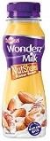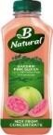**Cigarettes** **FOODS** **PERSONAL CARE**

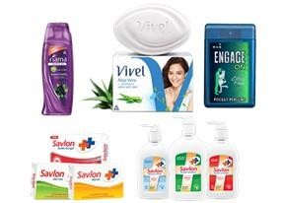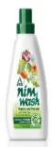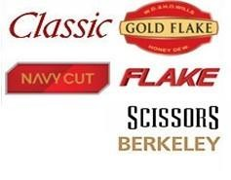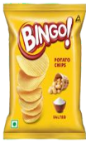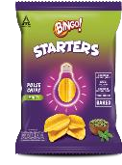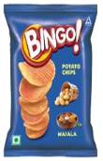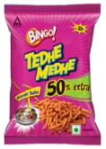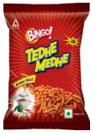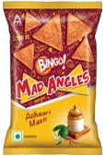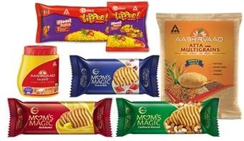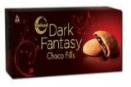

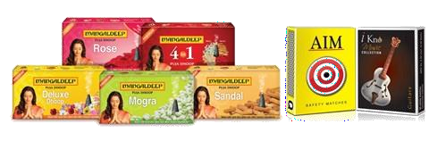**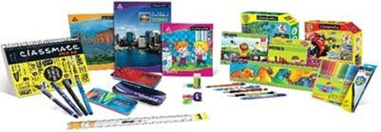Education & Stationery Safety Matches & Incense Sticks**

|  |
| --- |
| **OTHER BUSINESSES** |

**Paperboards, Paper & Packaging**

**HOTELS**





**INFORMATION TECHNOLOGY**

**AGRICULTURAL BUSINESS**

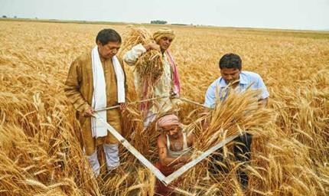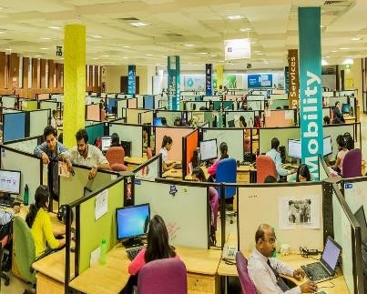



**FMCG PRODUCTS**

**Cigarettes**

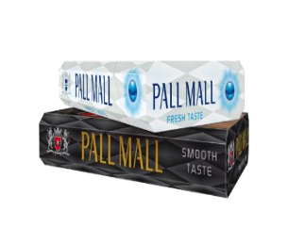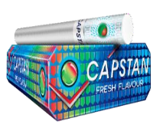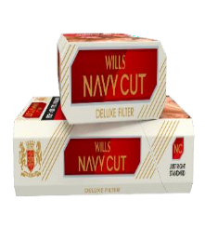

#### **Market leadership**

###### − Leadership across all segments – geographic & price

* **State-of-the-art technology and world-class products**
* **New variants introduced for catering to continuously evolving consumer preferences**
* Innovative and differentiated offerings such as Classic Rich & Smooth, Gold Flake Neo, Gold Flake Luxury Filter, Gold Flake Indie Mint, Wills Navy Cut Deluxe, Capstan Fresh and Flake (5’s pack)
* Focused offers for key markets under the ‘American Club’, ‘Wave’, ‘Player’s Gold Leaf’, ‘Pall Mall’ and ‘Flake’ trademarks



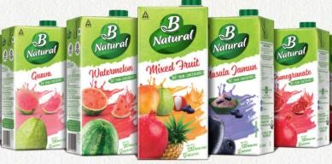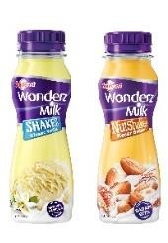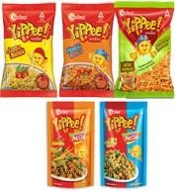**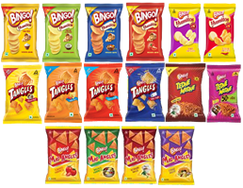BRANDED PACKGED FOODS**

**Biscuits, Staples, Snacks, Noodles & Pasta, Confectionery, Ready to Eat, Juices, Dairy, Chocolates and Coffee**

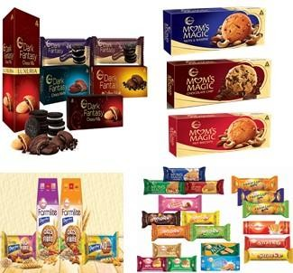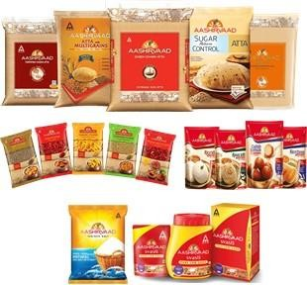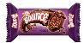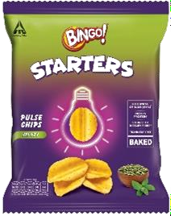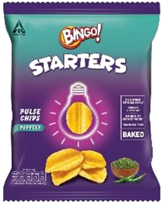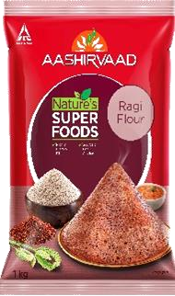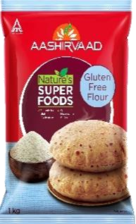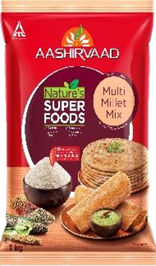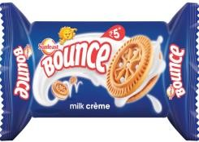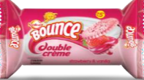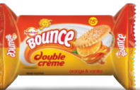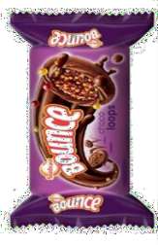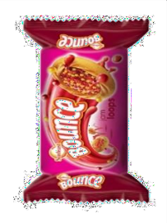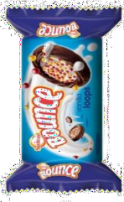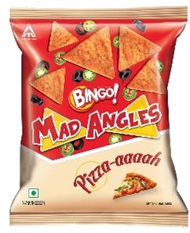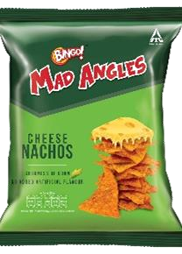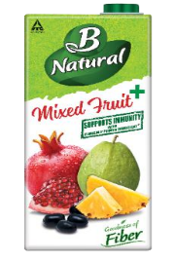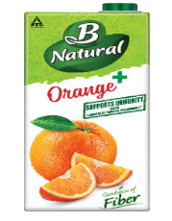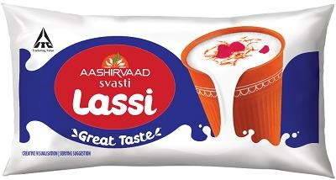

**BINGO! Starters Range B Natural BINGO! Mad Angles AASHIRVAAD SVASTI**

**(Immunity Range, Nagpur Orange) (Cheese Nachos & Pizza) (Lassi)**

**AASHIRVAAD Nature’s Super Foods Range SUNFEAST BOUNCE LOOPS SUNFEAST BOUNCE SUNFEAST**

**(Choco, Jam & Vanilla) (Double Cream) (Veda Marie Light)**

**SOME RECENT LAUNCHES**



**PERSONAL CARE PRODUCTS**

* The business continues to enhance market standing in the Fragrance and Liquid (Handwash & Bodywash) categories.

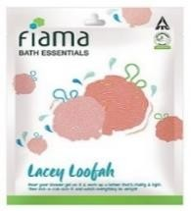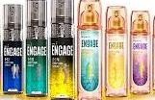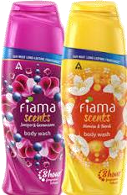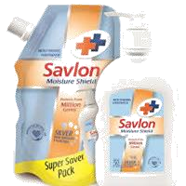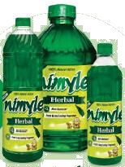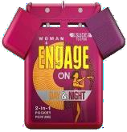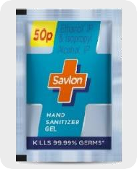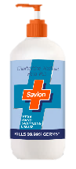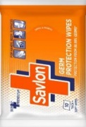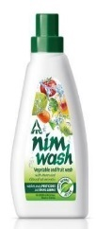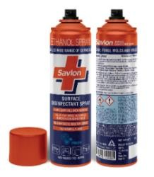

* **No 2 in Bodywash Categories**
* **‘Engage’** range deodorants continue to strengthen its market standing.
* **Pocket perfume range augmented with the launch of unique dual fragrance.**
* **Clear No 2 brand in category, No 1 in women’s segment**
* Recent category launch
* **Premium Skin Care Range- “Dermafique”**
* **Floor cleaner- “Nimyle”**
* **Fruit and vegetable cleaner- “Nimwash”**
* **Disinfectant spray- “Savlon”**
* **Germ protection wipe- “Savlon”**

### **RECENT LAUNCHES**

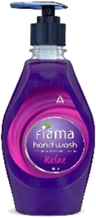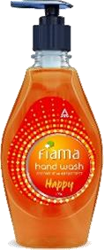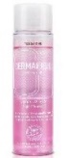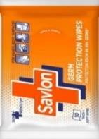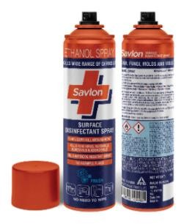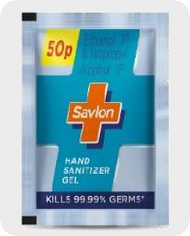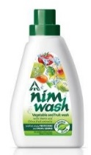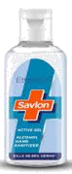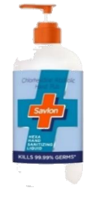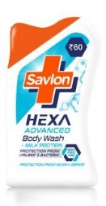

**NIMWASH**

**FIAMA MENTHOL & MANGOLIA**

**DERMAFIQUE RANGE EXTENTION**

**ENGAGE L’MANTE**

**FIAMA HANDWASH**

**SAVLON WIPES**

**SAVLON HAND SANITIZER(POUCH)**

**SAVLON HEXA**

**HAND SANITIZER, SOAP & BODYWASH**

**SAVLON DISINFECTANT SPRAY**



**EDUCATION & STATIONARY PRODUCTS**

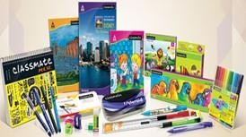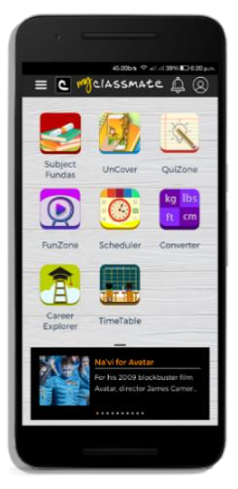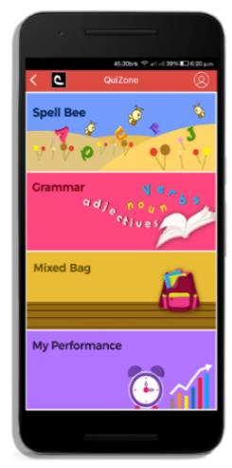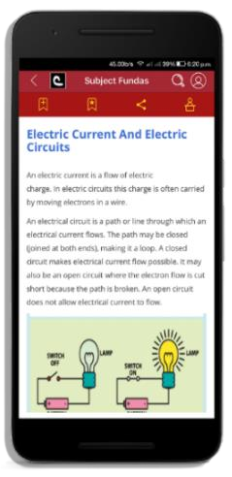

**MyClassmate APP**

* **Leverage Company’s paper & printing expertise and distribution network**

- Classmate, Saathi and Paperkraft brands continue to enhance market standing

* Industry growth driven by increasing literacy and enhanced scale of government and public-private education initiatives
* Increase presence in **writing instruments & scholastic products** segment leveraging the Classmate brand
* **Classmate** is the Market leader in Notebooks segment
* Deepening consumer engagement through **Classmateshop.com &**  **MyClassmate app** to deliver customised notebooks
* A dedicated **manufacturing facility for notebooks**, equipped with state-of-the-art machinery was commissioned at **Gollapudi, Andhra Pradesh**



**Safety Matches & Incense Sticks**

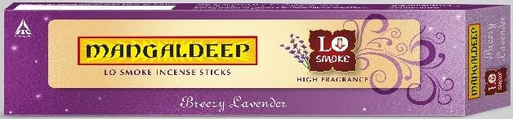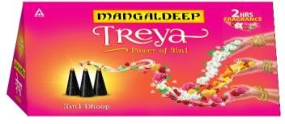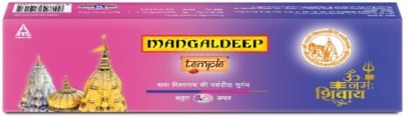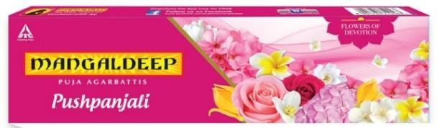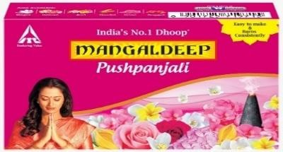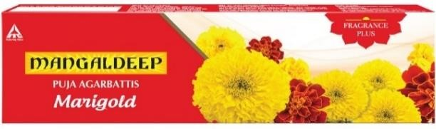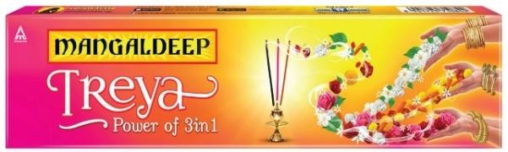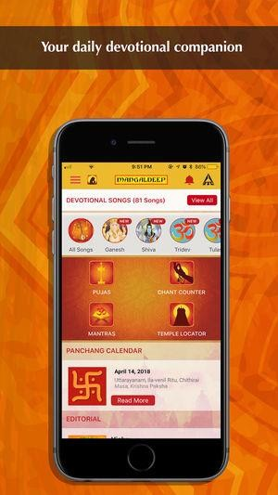

**8 lakh+ downloads; 37,000+ active users**

* **‘Mangaldeep**’ continues to fortify its market standing in the Agarbatti and Dhoop segment.
* ‘**AIM**’ continues to be the largest selling safety matches brand in India.
* **Mangaldeep App** caters to the everyday devotional needs of consumers.
* The Business launched several innovative offerings incl. ‘Mangaldeep **Lo Smoke** Agarbattis’ (80% lesser smoke) & Mangaldeep **Temple range** of dual fragranced agarbattis**.**



ITC’s World Class Indian Brands

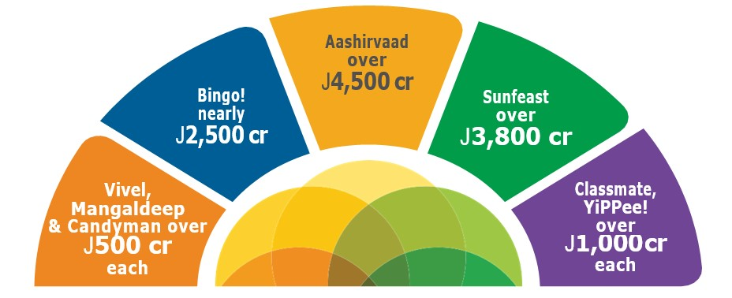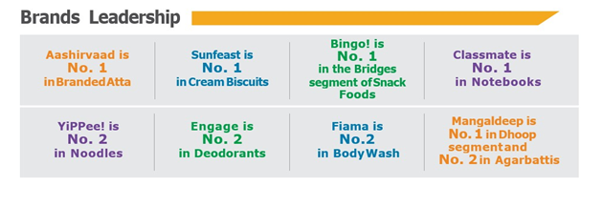

**Consumer Spend**



|  |
| --- |
| **HOTELS** |

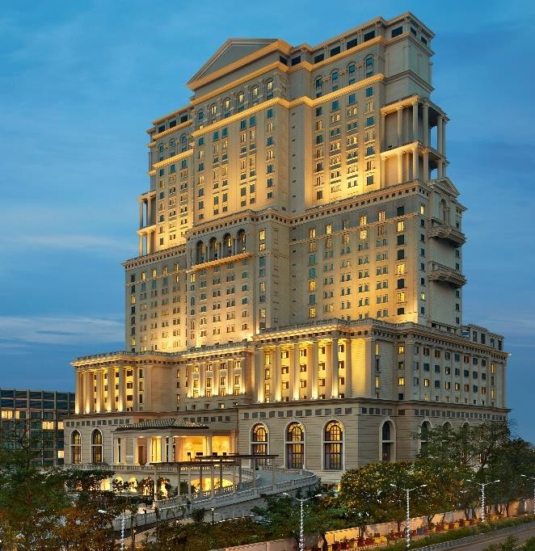

**ITC ROYAL BENGAL**

**ITC KOHENUR**



**ITC GRAND GOA**

* **The Chain**: 108 properties over 70 locations

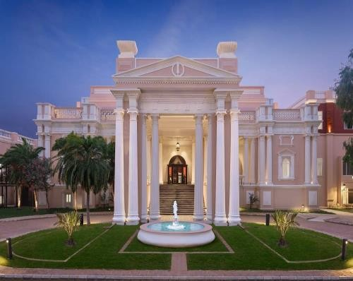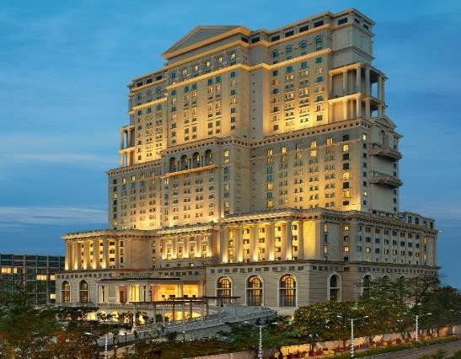

* 4 Brands: ‘ITC Hotels’ in the Luxury segment, ‘**Welcomhotels**’ in the Upper-Upscale segment, ‘**Fortune**’ in the Mid-market to Upscale segment and ‘**WelcomHeritage**’ in the Leisure & Heritage segment
* 30 Five-Star Deluxe/ Five-Star Properties with nearly 6200 rooms
* 42 Fortune Hotels with nearly 3100 rooms
* 36 WelcomHeritage Properties with nearly 900 rooms
* **Enhancing Business scale by adopting ‘asset-right’ strategy –** Managed properties now account for more than 50% of room inventory of ITC hotels group.
* **New iconic properties commissioned recently – ITC Royal Bengal, Kolkata** (455 room hotel) and **Welcomhotel** Amritsar (101 room hotel)
* **Projects underway**:
* ITC Hotel at Ahmedabad
* Welcomhotels at Bhubaneswar & Guntur

|  |
| --- |
| **Paperboards, Paper & Packaging** |



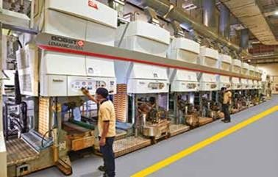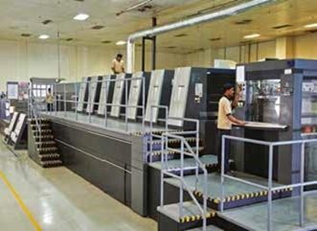

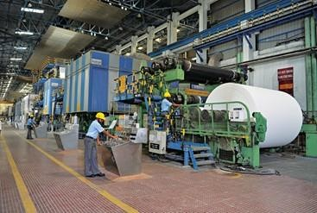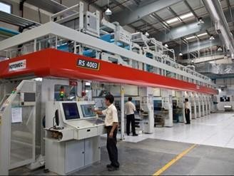

* Market leader in **Value-Added Paperboards (VAP)** segment
* **World-class technology & quality**

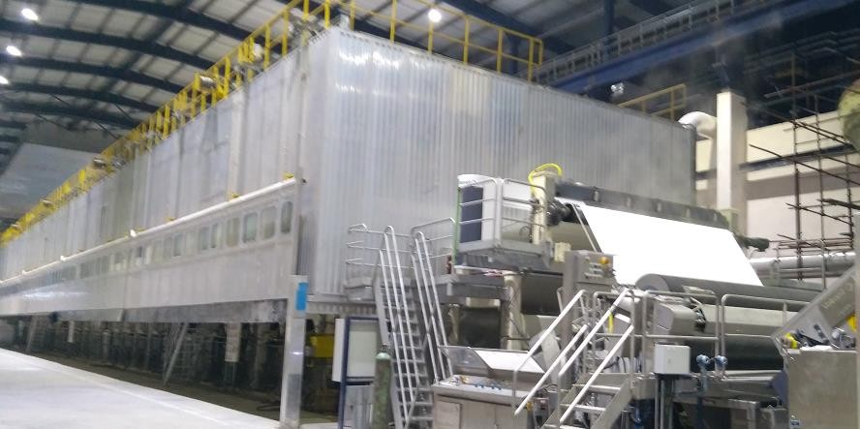

**VAP Machine**

* Fully integrated Ozone bleached Pulp Mill (3.5 lakh TPA) – one of its kind in Asia meeting world- class environmental standards.
* India’s first Bleached Chemical Thermo Mechanical Pulp (BCTMP) mill, reduced dependence on imported pulp and source of competitive advantage.
* The diverse product range of the recently commissioned Décor machine well accepted by discerning customers.
* Rebuilt Value Added Paperboard (1.5 lakh TPA) line commissioned in Aug’18; operating at near-full capacity.
* **ITC’s packaging SBU** – India’s largest converter of Paperboard into high quality packaging
* Provides superior packaging solutions to cigarettes and other FMCG businesses.
* Leading supplier to Indian FMCG industry.
* One-stop-shop for packaging solutions.



|  |
| --- |
| **AGRICULTURAL BUSINESS** |

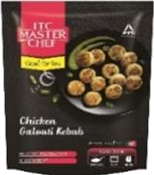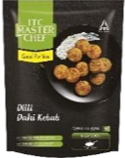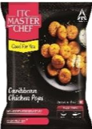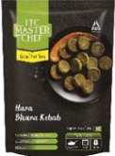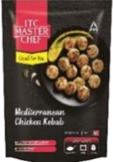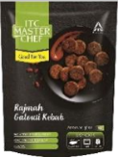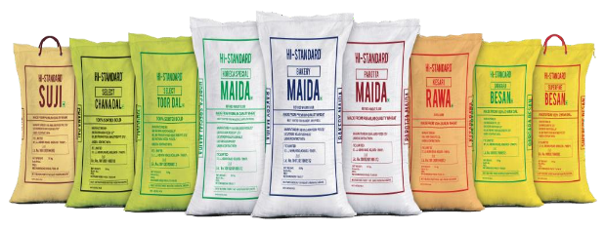

**Farmland Apples**

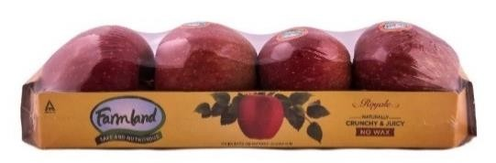

**Maida Suji Besan & Dal**

**ITC Master Chef Frozen** Snacks

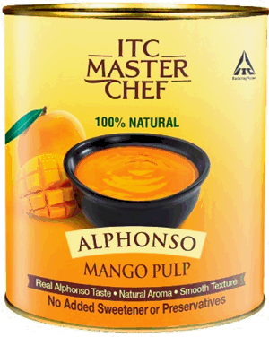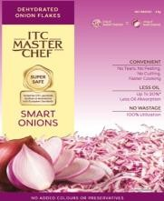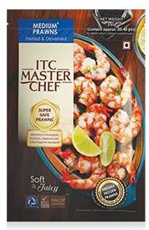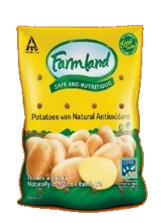

**ITC Master Chef Mango Puree**

**ITC Master Chef Super Smart Onions**

**ITC Master Chef Prawn**

**Farmland Potatoes**

* **Distinctive sourcing capability for ITC’s Branded Packaged Foods Businesses**
* Identity-preserved superior quality wheat for ‘Aashirvaad’ atta
* Superior quality Indian fruit pulp for ‘B Natural’ range of juices
* Sourcing support for ‘Aashirvaad’ and ‘ITC Master Chef’ spices
* Scale up in milk procurement for ‘Aashirvaad Svasti’ range dairy products
* **Farm linkages in 17 States** covering Wheat, Oilseeds, Coffee, Spices, Milk etc.
* **Unique Customer Relationship Management programme** for commodity customers in both domestic and international markets
* **Leveraging Information Technology for the transformational ‘e-Choupal’** initiative
* Rural India’s largest Internet-based intervention with over 35000 villages linked through around 6100 e-Choupals servicing about 4 million farmers
* Cost-effective sourcing for exports/domestic external business



|  |
| --- |
| **INFORMATION TECHNOLOGY** |

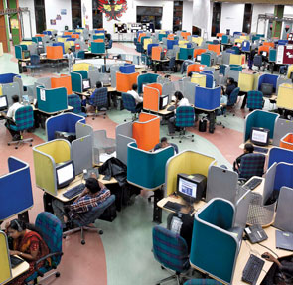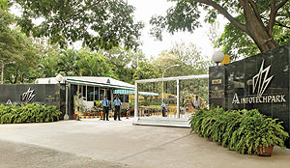

**ITC Infotech**, a global IT services company, is today one of India’s fastest growing IT and ITES service providers. Since it’s inception in October 2000, the company has established itself as key player in offshore outsourcing, providing outsourced IT solutions and services to leading global customers.

While an enterprise range of technology capabilities and world class quality processes form the foundation of ITC Infotech’s cutting-edge IT service strength, a sharp domain focus ensures that IT and IteS delivery always places business needs ahead of technology.

 The company enjoys the rare advantage of having a practitioner’s expertise with a strong vertical focus in **Consumer Packaged Goods (CPG) and Retail, Travel, Hospitality and Transportation,** and Manufacturing – domains that its parent, ITC Limited, has traditionally dominated – as well as in the main stay of technology service providers: **Banking, Financial Services and Insurance.**

ITC Infotech offers services through a global delivery platform with a strength of over 2,000 employees and delivery centers across North America, Europe and Asia-Pacific that serve Fortune-listed companies in 42 countries.

 ITC Infotech conforms to the highest standards in international process quality, with ISO 27001, ISO 9001, SEI CMM Level 5 and BS 7799 accreditations. These reflect the company’s ongoing enterprise-wide focus to ensure that every engagement, program and project delivers international quality consistently.



**AWARDS & ACCOLADES OVER THE YEARS**

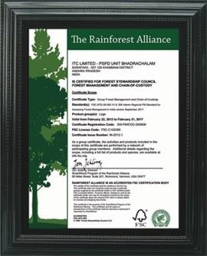

ITC conferred the prestigious ‘World Business and Development Award 2012’ at the Rio+20 UN Summit for its Social and Farm Forestry Initiatives.

**Rainforest Alliance awarded ITC's Bhadrachalam Unit, the Forest Stewardship Council Forest Management certification.**

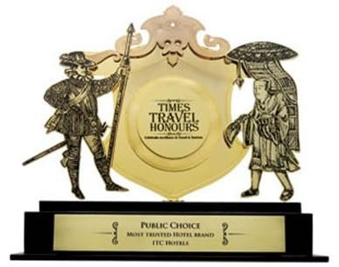

**ITC Hotels awarded the ‘Most Hotel brand’ Public Trusted in the Choice Honours category at the Times Travel Honours**

Business world FICCI CSR award in Large Enterprise category

**AIM Asian CSR Award by the Asian Forum on Corporate Social Responsibility**

**Essenza Di Wills wins Silver for ‘Video Craft’ in Cinematography category at ABBY Awards 2019**

**Dermafique wins Cosmopolitan Awards 2019 for ‘Best Body lotion’ and ‘Best BB Cream’**

**Mangaldeep wins Digital Crest Awards 2019 for ‘Best Mobile App’.**

**Sunfeast Farmlite bagged Bronze for ‘Video Craft’ in Music category at ABBY Awards 2019.**

**Best Overall Corporate Social Responsibility Performance: Institute of Public Enterprise**



**Governance Structure Of ITC**

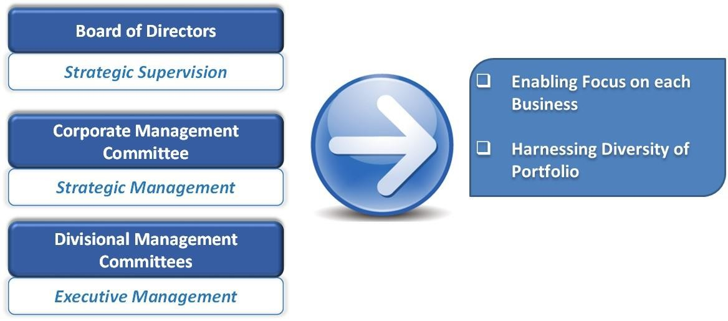The Company’s Corporate Governance processes are designed to support effective management of multiple businesses while retaining focus on each one of them. The practice of Corporate Governance at ITC takes place at three interlinked levels.

* **Governance Structure:**

**CORPORATE MANAGEMENT COMMITTEE**

**DIVISIONAL/SBU MANAGEMENT COMMITTEE**

Divisional/SBU Management Committees, each headed by a Divisional/SBU Chief Executive

### Businesses include**:**

### **FMCG, Hotels, Paperboards, Specialty Papers & Packaging, Agri Business and Information Technology**

**CORPORATE FUNCTIONS**

Corporate Functions, each headed by a Head of Department

Corporate Functions include:

Planning & Treasury, Accounting, Taxation, Risk Management, Legal, Secretarial, Internal Audit, EHS, Human Resources, Corporate Communications, Corporate Affairs, Research & Development, Central Projects Organization and IT Support Services.

**CSR AND SUSTAINABILITY**

**COMMITTEE**

**AUDIT NOMINATION & COMMITTEE COMPENSATION**

**COMMITTEE**

**STAKEHOLDERS INDEPENDENT RELATIONSHIP DIRECTORS**

**COMMITTEE COMMITTEE**

**BOARD OF DIRECTORS**

|  |
| --- |
| **BOARD OF DIRECTORS** |



|  |  |  |
| --- | --- | --- |
| **Director** | **No of Directorship(s)** | **No. of Membership(s) [including Chairmanship(s)] of Board Committees of other companies** |
| **EXECUTIVE DIRECTORS** | | |
| Y. C. Deveshwar (Chairman) | 1 | Nil |
| N. Anand | 8 | 1 |
| P. V. Dhobale | Nil | Nil |
| K. N. Grant | 2 | 1 |
| **NON-EXECUTIVE DIRECTORS** | | |
| A. Baijal | 3 | 1 (As Chairman) |
| A. V. Girija Kumar | 1 | Nil |
| S. H. Khan | 6 | 9 (Including 4 as Chairman) |
| R. E. Lerwill | Nil | Nil |
| S. B. Mathur | 12 | 8 (Including 3 as Chairman) |
| P. B. Ramanujam | Nil | Nil |
| S. S. H. Rehman | Nil | Nil |
| A. Ruys | Nil | Nil |
| M. Shankar (Ms) | Nil | Nil |
| K. Vaidyanath | Nil | Nil |



|  |
| --- |
| **DISTRIBUTION NETWORK OF ITC LTD** |

**Distributor**

**Retailers**

**Manufacturing Unit-ATTA**

**Manufacturing Unit-Food Products**

**Manufacturing Unit-Biscuits**

**Manufacturing Unit-Cigarettes**

**Malls**

**Pandabbas**

**Whole Seller**

**HUB**

**Small Retailers**



**AN OVERVIEW OF PROJECTS**

1. **MARKET RESEARCH**

Market research exists to guide business decisions by giving an insight about the market, competitors, products, marketing and customers. By enabling to make informed choices, market research will help to develop a successful marketing strategy.

Market research helps reduce risks by allowing to get product, price and promotion right from the outset. It also helps in focusing resources where they'll be most effective.

There are two main types of market research - quantitative research and qualitative research.

**Quantitative research** focuses on coming up with numbers: for example, what percentage of the population buys a particular product. It's gathered using surveys and questionnaires. More in-depth quantitative research can be used to identify markets and understand customer profiles - vital if new products are going to be launched.

**Qualitative research** gets behind the facts and figures to find out how people feel about products and what factors affect their buying decisions. Researchers use questionnaires and focus groups to gather this intelligence, while interpreting the results is a skilled job.

1. **PRODUCT RESEARCH**

Product research helps us to refine product design and features before committing to expensive product development costs. Regular product testing and market research can drive innovation over time, keeping one step ahead of the competition.

Product research is a vital part of new product development. At every stage of the process, research can help you identify key issues and avoid expensive mistakes.

Initial product research can be used to evaluate new ideas. Testing a concept can help you discard unpromising ideas, allowing you to concentrate your time and money on products with the best chance of achieving commercial success.

It's also well worth creating a "Minimum Viable Product" (MVP), a simple version that you can use to get customer feedback at the earliest possible stage.



**MARKET RESEARCH**

**Research Objectives:**

1. To find out Unserved outlets of ITC.
2. To find out potentiality of taking ITC’s Savlon products in terms of health & hygiene during COVID-19.
3. To find out distribution of Competitor’s product of ITC on the ground of health & hygiene during COVID-19.
4. To find out most of newly evolved outlets which are willing to keep health & hygiene products for their new source of income in the environment of COVID-19
5. To find out Most demanded product in the pandemic of COVID-19 in health & hygiene sector.
6. To find out how to penetrate in unserved outlets with new set of health & hygiene products.
7. To find out mostly unserved area under a Distributor point.

**Methodology:**

Research Methodology can consider research as movement, a movement from the known to the unknown. The term Research methodology is an academic activity and as such the term should be used in technical sense. According to Clifford Woody research comprises defining and redefining problems, formulating hypothesis or suggested solutions, collecting, organizing and evaluating data, making deduction and reaching conclusions and then testing of the conclusion to determine whether they fit it in the formulating hypothesis.

**Source of data-** The Data was collected direct from the market. This type of first hand data is called **Primary Data**. Such data is original in character and is generated by surveys conducted by individuals or research institutions.

**Instrument-** **Questionnaire** and **Observation** were used as the instruments of data collection. Observation was on the basis of the products that were being displayed at the time of visit. Questionnaire was performed through some open-ended and close-ended questions like Background questions, intensity questions.

**Sampling Techniques-** The sampling method was **Random sampling**. Data was collected randomly from the market as per convenience from the assigned market has been given to me.

**Sampling Frame-** The sampling frame was the convenient retail outlet. Retailers were interviewed to get their opinion about details of the health & hygiene products.

**Sampling Frame-** The sample size is 106.

**Location-** Location was based on the markets those are assigned under **Belgharia Distributor Point**.

**Data Analysing Technique-** By analysing the data and chats made on the basis of collected data.

**Data Analysis:**

|  |  |  |
| --- | --- | --- |
| **TOTAL NUMBER OF UNSERVED OUTLETS** | | |
| Shop Name | Shop Count | Percentage Count |
| Gift Shop | 4 | 3.77% |
| Garments | 13 | 12.26% |
| Hardware | 15 | 14.15% |
| Furniture | 2 | 1.89% |
| Electronics | 8 | 7.55% |
| Grocery | 5 | 4.72% |
| Medicine | 20 | 18.87% |
| Mobile Store | 2 | 1.89% |
| Optical Shop | 4 | 3.77% |
| Cosmetics | 12 | 11.32% |
| Shoe Store | 3 | 2.83% |
| Colour Shop | 2 | 1.89% |
| Stationary | 7 | 6.60% |
| Others | 1 | 0.94% |
| Bag Store | 1 | 0.94% |
| Builders | 3 | 2.83% |
| Parlour | 1 | 0.94% |
| Studio | 1 | 0.94% |
| Saloon | 2 | 1.89% |
| **Total** | **106** | **100%** |



* **INTREPRETATION**: - Here, I found top 5 unserved Shops under the Belgharia Distributor point are presenting in descending order- **1) Medicine Shop, 2) Hardware shop, 3) Garment Shops, 4) Cosmetic Shops, 5) Electronics.**

|  |  |  |
| --- | --- | --- |
| **AREAWISE UNSERVED OUTLETS** | | |
| Area | Count | Percentage |
| Belgharia | 43 | 41% |
| Durganagar | 20 | 19% |
| Birati | 8 | 8% |
| Pathanpur | 2 | 2% |
| Nimta | 20 | 19% |
| B.T Road | 4 | 4% |
| Airport | 9 | 8% |
| **Total** | **106** | **100%** |

* **INTREPRETATION**: - Here, the top 3 unserved area under Belgharia Distributor are- **1) Belgharia, 2) Durganagar, 3) Nimta.**



|  |  |  |
| --- | --- | --- |
| **CUSTOMER TYPE** | | |
| Hot | 55 | 51.89% |
| Cold | 51 | 48.11% |
| **Total** | **106** | **100.00%** |

* **INTREPRETATION**: - Here I found **51.89%** of the total number of outlets are ready to be converted immediately.

|  |  |
| --- | --- |
| **AREAWISE HOT CUSTOMERS** | |
| |  |  |  | | --- | --- | --- | | **Belgharia** | | | | Garments | 3 | 27% | | Hardware | 2 | 18% | | Electronics | 1 | 9% | | Medicine | 3 | 27% | | Cosmetics | 2 | 18% | | **Total** | **11** | **100%** | |  |
| |  |  |  | | --- | --- | --- | | **Durganagar** | | | | Garments | 0 | 0% | | Hardware | 0 | 0% | | Electronics | 0 | 0% | | Medicine | 6 | 75% | | Cosmetics | 2 | 25% | | **Total** | **8** | **100%** | |  |
| |  |  |  | | --- | --- | --- | | **Nimta** | | | | Garments | 0 | 0% | | Hardware | 7 | 50% | | Electronics | 0 | 0% | | Medicine | 2 | 14% | | Cosmetics | 5 | 36% | | **Total** | **14** | **100%** | |  |



|  |  |
| --- | --- |
| **SHOPWISE CUSTOMER TYPES** | |
| |  |  |  | | --- | --- | --- | | **Medicine** | | | | Hot | 16 | 80% | | Cold | 4 | 20% | | **TOTAL** | **20** | **100%** | |  |
| |  |  |  | | --- | --- | --- | | **Hardware** | | | | Hot | 10 | 66.67% | | Cold | 5 | 33.33% | | **TOTAL** | **15** | **100.00%** | |  |
| |  |  |  | | --- | --- | --- | | **Garments** | | | | Hot | 4 | 30.77% | | Cold | 9 | 69.23% | | **TOTAL** | **13** | **100.00%** | |  |
| |  |  |  | | --- | --- | --- | | **Cosmetics** | | | | Hot | 10 | 83% | | Cold | 2 | 17% | | **TOTAL** | **12** | **100%** | |  |
| |  |  |  | | --- | --- | --- | | **Electronics** | | | | Hot | 2 | 25% | | Cold | 6 | 75% | | **TOTAL** | **8** | **100%** | |  |



|  |  |  |
| --- | --- | --- |
| **DISTRIBUTION OF DEMAND OF ITC PRODUCTS** | | |
| **Product Name** | **Count** | **Percentage** |
| Hand Sanitizer | 56 | 36.13% |
| Disinfectant Spray | 33 | 21.29% |
| Anti Septic Liquid | 34 | 21.94% |
| Wipe | 6 | 3.87% |
| Soap | 9 | 5.81% |
| Nimyle | 15 | 9.68% |
| Nim wash | 2 | 1.29% |
| **Total** | **155** | **100.00%** |

* **INTREPRETATION**: - The most demanded product in the crisis of COVID-19 is **Hand Sanitizer**. Following that **Anti Septic Liquid** and **Disinfectant Spray.**

|  |  |  |
| --- | --- | --- |
| **COMPETITOR’S DISTRIBUTION** | | |
| **Company Name** | **Distribution Count** | **Percentage** |
| HUL | 25 | 13.59% |
| RB | 45 | 24.46% |
| Dabur | 23 | 12.50% |
| Marico | 17 | 9.24% |
| Godrej | 17 | 9.24% |
| Other | 57 | 30.98% |
| **Total** | **184** | **100.00%** |

* **INTREPRETATION**: - The local market is mostly captured by **Local Brands** took birth in the crisis of COVID situation and after that most spread brand is **Reckitt Benckiser (Dettol)**.



**Observation & Findings:**

* **High demand** of **Hand Sanitizer** is floating around the market.
* Most of the market have been already covered by the **Local Brands**.
* **Maximum** unserved outlets have been found in **Belgharia** region.
* **Maximum** demand was found in **Medical Shops**.
* New products of Savlon are in **Introductory Stage**.
* There is high potentiality of grabbing new and unserved customers as there are lots of existing shops dealing with different types of products are willing to do business with health & hygiene products as their new source of income.

**Suggestion:**

1. All health & hygiene products should be well distributed as there is already a huge demand of health & hygiene products in the market.
2. Most unserved areas should be well monitored.
3. Frequent follow up of unserved shops should be scheduled in weekly or monthly manner.
4. Better promotional strategy must be formulated to face the tough competitions.
5. Attractive customer Schemes should be introduced.
6. Better Service support should be provided.
7. Distribution process should be well equipped so that products will be delivered with a very short span of time.
8. Advertisement could be well platform for mass awareness.



**PRODUCT RESEARCH**

**Research Objectives:**

1. To find out how Savlon gets prioritize in terms of health & hygiene products in recent pandemic situation.
2. To find out responsiveness of the Savlon products keeping mind of health & hygiene.
3. To find out distribution of health & hygiene products of Savlon.
4. To find out most selling and low selling health & hygiene products of Savlon.
5. To find out awareness of newly released products of ITC amongst people.

**Questions have been asked for survey:**

1. What kind of personal care products of Savlon you used recently?
2. How was your last experience with Savlon product?
3. Are you satisfied with the product price?
4. Is Savlon product available in your nearby market?
5. How frequently you purchase Savlon product?
6. Which product of Savlon you like the most?
7. How long you are using Savlon products?
8. In which mode you want to use Hand sanitizer?
9. Which type of Hand Sanitizer is more convenient to you?
10. Have you tried new Savlon Disinfectant Spray?
11. Have you used newly launched Savlon Wipe?
12. Have you experienced new vegetable disinfectant "Nim Wash" of ITC?
13. Which type of Savlon Soap you prefer the most?
14. Which type of Savlon Handwash You prefer the most?
15. Which quantity of Savlon Handwash you usually buy for your family?
16. Do you have any Good experience with Savlon?
17. Do you have any Bad experience with Savlon?
18. Do you think all Savlon product have a pleasant Smell?
19. Would you like to give some opinion on Savlon products?
20. Would you recommend your dear one to use Savlon products?

**Methodology:**

Research Methodology can consider research as movement, a movement from the known to the unknown. The term Research methodology is an academic activity and as such the term should be used in technical sense. According to Clifford Woody research comprises defining and redefining problems, formulating hypothesis or suggested solutions, collecting, organizing and evaluating data, making deduction and reaching conclusions and then testing of the conclusion to determine whether they fit it in the formulating hypothesis.

* **TOOLS OF ANALYSIS**

To know the response. I have used the **questionnaire** method in sample survey. If one wishes to find what people think or know, the logical procedure is to ask them. This has led researchers to use the questionnaire technique for collecting data more than any other method. In this method questionnaire were distributed to the respondents and they were asked to answer questions in the questionnaire. The questionnaires were structured non-disguised questionnaire because the questions, which the questionnaire contained, were arranged in a specific order besides every question asked were logical for the study, no question can be termed as irrelevant. Analysis was done through **Percentage analysis.**

* **Data Collection**

Through online mode via Google form.

* **Sampling Technique**

The method used for sample technique was convenient sampling is used because only those people were asked to fill the questionnaires who were easily accessible and available to the researcher.

* **Sample Size**

105 customers were surveyed.

* **Sampling Frame**

Market potentiality of Health & Hygiene products.

* **Location**

Within Kolkata region.

* **Data analyse technique**

By analysing feedbacks with the help of chats.

**Concerned products:** 

1. Savlon Handwash
2. Savlon Hand Sanitizer
3. Savlon Soap
4. Savlon Antiseptic liquid
5. Vegetable Wash (Nim Wash)
6. Floor cleaner (Nimyle)
7. Savlon Disinfectant Spray

**Research Process:**

I created a google form containing those aforesaid questions and sent them to my friends and my family members to fill up. This process was done using the social media and information was received via online mode.

**Research design:**

* **Type of research design**- The research design that I have chosen is Exploratory Research design. I have tried to find out the overall performance and acceptability of Savlon health & hygiene products.
* **Information needs**- The information I needed at the time of survey was all the details about those products that I have selected for conducting the analysis.
* **Data collection from primary sources**- 105 responses have been collected from primary sources.
* **Data collection from secondary sources**- No data has been collected through secondary sources.
* **Scaling techniques**- I have used Itemized rating scale to collect the responses.
* **Questionnaire development and pretesting**- Questionnaire has been developed through google form and spread through internet media.
* **Sampling techniques**- The sampling technique I have used was Convenience Sampling. Survey was conducted among my closely related family and friends.

**Data Analysis:**

**Q1.** **What kind of personal care products of Savlon You used recently?**

|  |  |  |
| --- | --- | --- |
| **Options** | **No. of Respondents** | **Percentage of Respondents** |
| Hand Sanitizer | 48 | 26.23% |
| Anti-Septic Liquid | 36 | 19.67% |
| Savlon Soap | 28 | 15.30% |
| Handwash | 71 | 38.80% |
| **Total** | **183** | **100%** |

**Interpretation:**

**38.80%** of the respondents have used **Savlon Handwash** recently, **26.23%** of the respondents have used **Savlon Hand Sanitizer** recently, **19.67%** of the respondents have used **Savlon Anti Septic Liquid** recently, **15.30%** of the respondents have used **Savlon Soap** recently.



**Q2.** **How was your last experience with Savlon product?**

|  |  |  |
| --- | --- | --- |
| **Options** | **No. of Respondents** | **Percentage of Respondents** |
| Excellent | 29 | 27.62% |
| Good | 69 | 65.71% |
| Average | 7 | 6.67% |
| Bad | 0 | 0% |
| Worst | 0 | 0% |
| **Total** | **105** | **100** |

**Interpretation:**

**27.62%** of the respondents have marked Savlon product as **Excellent**, **65.71%** of the respondents have marked Savlon product as **Good, 6.67%** of the respondents have marked Savlon product as **Average, 0%** of the respondents have marked Savlon product as **Bad & Worst.**

**Q3. Are you satisfied with the product price?**

|  |  |  |
| --- | --- | --- |
| **Options** | **No. of Respondents** | **Percentage of Respondents** |
| Yes | 85 | 80.95% |
| No | 2 | 1.90% |
| Maybe | 18 | 17.14% |
| **Total** | **105** | **100%** |

**Interpretation:**

**80.95%** of the respondents are **Satisfied** with product price, **17.14%** of the respondents are **Somehow Satisfied** with product price, **1.90%** of the respondents are **Not Satisfied** with product price.



**Q4.** **Is Savlon product available in your nearby market?**



|  |  |  |
| --- | --- | --- |
| **Options** | **No. of Respondents** | **Percentage of Respondents** |
| Yes | 96 | 91.43% |
| No | 9 | 8.57% |
| **Total** | **105** | **100%** |

**Interpretation:**

**91.43%** of the respondents are saying that Savlon products is **Available** in their nearby market, **8.57%** of the respondents are saying that Savlon products is **Not Available** in their nearby market.

**Q5. How frequently you purchase Savlon product?**



|  |  |  |
| --- | --- | --- |
| **Options** | **No. of Respondents** | **Percentage of Respondents** |
| Once in a Month | 25 | 23.81% |
| Twice in a Month | 17 | 16.19% |
| Thrice in a Month | 1 | 0.95% |
| Whenever Required | 62 | 59.05% |
| **Total** | **105** | **100%** |

**Interpretation:**

**59.05%** of the respondents are brought Savlon products **Whenever they required**, **23.81%** of the respondents are brought Savlon products **Once in a month**, **16.19%** of the respondents are brought Savlon products **Twice in a month**, **0.95%** of respondents are brought Savlon products **Thrice in a month**.

**Q6. Which product of Savlon you like the most?** 



|  |  |  |
| --- | --- | --- |
| **Options** | **No. of Respondents** | **Percentage of Respondents** |
| Hand Sanitizer | 20 | 19.05% |
| Anti-Septic Liquid | 27 | 25.71% |
| Savlon Soap | 8 | 7.62% |
| Handwash | 50 | 47.62% |
| **Total** | **105** | **100%** |

**Interpretation:**

**47.62%** of the respondents prefer **Savlon Handwash**, **25.71%** of the respondents prefer **Savlon Anti Septic Liquid**, **19.05%** of the respondents prefer **Savlon Hand Sanitizer**, **7.62%** of respondents prefer **Savlon Soap.**

**Q7. How long you are using Savlon products?**

|  |  |  |
| --- | --- | --- |
| **Options** | **No. of Respondents** | **Percentage of Respondents** |
| Less than 1 Year | 15 | 14.29% |
| 1 Year | 12 | 11.43% |
| 2 Year | 13 | 12.38% |
| 3 Year | 8 | 7.62% |
| More than 3 Year | 57 | 54.29% |
| **Total** | **105** | **100%** |

**Interpretation:**

**54.29%** of the respondents are using Savlon for **more than 3 years**, **7.62%** of the respondents are using Savlon for **3 years, 12.38%** of the respondents are using Savlon for **2 Years**, **11.43%** of the respondents are using Savlon for **1 Year**, **14.29%** of the respondents are using Savlon for **less than 1 year.**



**Q8. In which mode you want to use Hand sanitizer?**



|  |  |  |
| --- | --- | --- |
| **Options** | **No. of Respondents** | **Percentage of Respondents** |
| Spray mode | 49 | 46.67% |
| Rub mode | 56 | 53.33% |
| **Total** | **105** | **100%** |

**Interpretation:**

**46.67%** of the respondents prefer Hand Sanitizer in **Spray mode**, **53.33%** of respondents prefer Hand Sanitizer in **Rub mode**.

**Q9. Which type of Hand Sanitizer is more convenient to you?**

|  |  |  |
| --- | --- | --- |
| **Options** | **No. of Respondents** | **Percentage of Respondents** |
| 55ml | 16 | 15.24% |
| 100ml | 51 | 48.57% |
| 200ml | 24 | 22.86% |
| 500ml | 10 | 9.52% |
| 5Lt | 4 | 3.81% |
| **Total** | **105** | **100%** |

**Interpretation:**

**48.57%** of the respondents prefer **100ml** Hand Sanitizer, **22.86%** of the respondents prefer **200ml** Hand Sanitizer, **15.24%** of the respondents prefer **55ml** Hand Sanitizer, **9.52%** of the respondents prefer **500ml** Hand Sanitizer, **3.81%** of the respondents prefer **5000ml** Hand Sanitizer.



**Q10. Which quantity of Savlon Handwash you usually buy for your family?**

|  |  |  |
| --- | --- | --- |
| **Options** | **No. of Respondents** | **Percentage of Respondents** |
| Savlon Chota Bhim(80ml) | 21 | 20% |
| 175ml | 13 | 12.38% |
| 200ml | 45 | 42.86% |
| 500ml | 14 | 13.33% |
| 750ml | 12 | 11.43% |
| **Total** | **105** | **100%** |

**Interpretation:**

**42.86%** of the respondents prefer **200ml** Handwash, **20%** of the respondents prefer **80ml** Handwash, **13.33%** of the respondents prefer **500ml** Handwash, **12.38%** of the respondents prefer **175ml** Handwash, **11.43%** of the respondents prefer **750ml** Handwash.

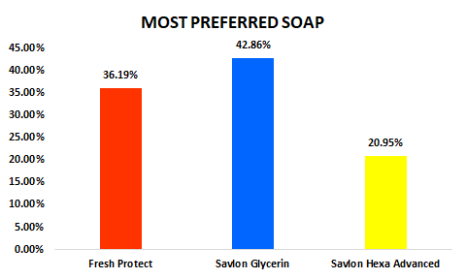**Q11. Which type of Savlon Soap you prefer the most?**

|  |  |  |
| --- | --- | --- |
| **Options** | **No. of Respondents** | **Percentage of Respondents** |
| Fresh Protect | 38 | 36.19% |
| Savlon Glycerine | 45 | 42.86% |
| Savlon Hexa Advanced | 22 | 20.95% |
| **Total** | **105** | **100%** |

**Interpretation:**

**42.86%** of the respondents prefer **Savlon Glycerine Soap**, **36.19%** of the respondents prefer **Savlon Fresh Protect Soap**, **20.95%** of the respondents prefer **Savlon Hexa Advanced Soap**.



**Q12. Which type of Savlon Handwash You prefer the most?**

|  |  |  |
| --- | --- | --- |
| **Options** | **No. of Respondents** | **Percentage of Respondents** |
| Moisturizer Shield | 39 | 37.14% |
| Herbal Sensitive | 30 | 28.57% |
| Deep clean | 36 | 34.29% |
| **Total** | **105** | **100%** |

**Interpretation:**

**37.14%** of the respondents prefer **Savlon Moisturizer Shield Handwash**, **34.29%** of the respondents prefer **Savlon Deep Clean Handwash**, **28.57%** of the respondents prefer **Savlon Herbal Sensitive Handwash**.

**Q13. Have you tried new Savlon Disinfectant Spray?**

|  |  |  |
| --- | --- | --- |
| **Options** | **No. of Respondents** | **Percentage of Respondents** |
| Yes | 28 | 26.67% |
| No | 77 | 73.33% |
| **Total** | **105** | **100%** |

**Interpretation:**

**73.33%** of the respondents are **Aware** of Savlon Disinfectant Spray, **26.67%** of the respondents are **Not** **Aware** of Savlon Disinfectant Spray.



**Q14. Have you used newly launched Savlon Wipe?**

|  |  |  |
| --- | --- | --- |
| **Options** | **No. of Respondents** | **Percentage of Respondents** |
| Yes | 10 | 9.52% |
| No | 95 | 90.48% |
| **Total** | **105** | **100%** |

**Interpretation:**

**90.48%** of the respondents are **Not** **Aware** of Savlon Wipe, **9.52%** of the respondents are **Aware** of Savlon Wipe.

**Q15. Have you experienced new vegetable disinfectant "Nim Wash" of ITC?**

|  |  |  |
| --- | --- | --- |
| **Options** | **No. of Respondents** | **Percentage of Respondents** |
| Yes | 20 | 19.05% |
| No | 85 | 80.95% |
| **Total** | **105** | **100%** |

**Interpretation:**

**80.95%** of the respondents are **Not** **Aware** of Savlon Nim wash, **19.05%** of the respondents are **Aware** of Savlon Nim Wash.



**Q16. Do you have any Good experience with Savlon?**

|  |  |  |
| --- | --- | --- |
| **Options** | **No. of Respondents** | **Percentage of Respondents** |
| Yes | 69 | 65.71% |
| No | 36 | 34.29% |
| **Total** | **105** | **100%** |

**Interpretation:**

**65.71%** of the respondents **Have good Experiences with Savlon**, **34.29%** of the respondents **Don’t Have good Experiences with Savlon**.

**Q17. Do you have any Bad experience with Savlon?**

|  |  |  |
| --- | --- | --- |
| **Options** | **No. of Respondents** | **Percentage of Respondents** |
| Yes | 2 | 1.90% |
| No | 103 | 98.10% |
| **Total** | **105** | **100%** |

**Interpretation:**

**98.10%** of the respondents have **No Complaint** against Savlon, **1.90%** of the respondents have **complaint** against Savlon.



**Q18. Do you think all Savlon product have a pleasant Smell?**

|  |  |  |
| --- | --- | --- |
| **Options** | **No. of Respondents** | **Percentage of Respondents** |
| Yes | 93 | 88.57% |
| No | 12 | 11.43% |
| **Total** | **105** | **100%** |

**Interpretation:**

**88.57%** of the respondents are **Satisfied** with product odor, **11.43%** of the respondents are **Not Satisfied** with product odor.

**Q19. Would you like to give some opinion on Savlon products?**

|  |  |  |
| --- | --- | --- |
| **Options** | **No. of Respondents** | **Percentage of Respondents** |
| Yes | 20 | 19.05% |
| No | 85 | 80.95% |
| **Total** | **105** | **100%** |

**Interpretation:**

**19.05%** of the respondents **Have Given** their suggestions on Savlon, **80.95%** of the respondents **Haven’t given** any suggestions on Savlon.



**Q20. Would you recommend your dear one to use Savlon products?**

|  |  |  |  |
| --- | --- | --- | --- |
| **Options** | **No. of Respondents** | **Percentage of Respondents** | |
| Yes | 105 | 100% | |
| No | 0 | 0% | |
| **Total** | | **105** | **100%** |

**Interpretation:**

**100%** of the respondents are ready to give product **Reference** to others.

**CONSUMER’S VOICE**

|  |  |
| --- | --- |
| **APPRECIATION** | **Need Improvement** |
| “Good quality”  “Good quality and affordable products”  “Good product”  “It is very good. It doesn't dry out my hands”  “a friend of mine gifted it to me”  “Good, effective”  “Because of its quality and affordable prices”  “It meets all my expectations”  “Quality and smell are good”  “Good product”  “The products are very good, comes at a good price and user friendly.”  “After shaving there is no better option left other than Savlon.”  “Savlon antiseptic liquid prevents my body rashes.”  “It is a good product to buy within a affordable range”  “It's really good.”  “The smell is too good”  “I always use Savlon Antiseptic liquid to heal small wound. It helps quickly and satisfactorily.”  "Irritation free”  “Nice to use”  “Antiseptic and protective effect is satisfactory enough for daily cleaning.”  “Good Product Quality “  “VERY USEFULL AND GOOD ANTISEPTIC”  “It is a cost-effective product but please do not raise the price high taking advantage of the current situation”  “Savlon products are quality wise good enough and very useful”  “Outstanding product portfolio”  “It is very good for health and it is a very popular and healthy brand.”  “Good antiseptic and protective formula for daily use.”  “Good quality products to have in this pandemic as well as normal conditions...”  “Always focus on quality of the product but reasonable price because all types of people can afford it.” | **“Want More availability in local stores”**  **“Many products of savlon are not available in all stores.”**  **“Need more development like people preferred spray sanitizer than rub sanitizer. including smelling part also.”**  **“Savlon hand sanitizer & hand wash both products are my favourite.... But, it's not available our local market... Mainly Hand Sanitizer...”**  **“Please make the products easily available to customers”** |



**Product Life Cycle:**

Introduction Stage Growth Stage Maturity Stage Decline Stage

S

A

L

E

S

Savlon Wipe, Savlon Disinfectant Spray, Nim Wash

Savlon Handwash, Savlon Anti Septic Liquid

Savlon Hand Sanitizer, Savlon Soap

Time

**SWOT Analysis:**

|  |  |
| --- | --- |
| **Strengths** | **Weaknesses** |
| * Well brand awareness. * Mostly availability of products * Good consumer response * Reliable price * Savlon products has been running for more than 3 years | * Savlon soaps are not so much popular * Newly launched products are not well distributed * Savlon wipe and Disinfectant spray are mostly unknown to all * Less number of repetitive buyers |
| **Opportunities** | **Threats** |
| * Huge demand of Savlon Anti septic liquid * Huge growth potential of health & hygiene products due to COVID situation * New stores are willing to keep health & hygiene products * Now a day’s peoples do not stick with one brand due to this crisis | * Many local brands are emerging * Not adequate supply of these products * Somehow Dettol created more brand loyalty than Savlon * In terms of health & hygiene Dettol supress Savlon most of the cases * Customers are losing faith due to unavailability of Savlon products |



**BCG Matrix: -**

**M A R K E T S H A R E**

|  |  |
| --- | --- |
| **SAVLON HANDWASH, SAVLON ANTI SEPTIC LIQUID**  **(High Growth, High Market Share)** | **NIMYL, SAVLON WIPE**  **(High Market Share, Low growth)** |
| **SAVLON HAND SANITIZER,**  **SAVLON SOAP, DISINFECTANT SPRAY**  **(Low Market Share, High Growth)** | **(Low Market Share, Low Growth)** |

**M**

**A**

**R**

**K**

**E**

**T**

**G**

**R**

**O**

**W**

**T**

**H**

**RECOMENDATIONS:**

|  |  |
| --- | --- |
| **Facts** | **Solutions** |
| Responses on Savlon Handwash is quite well. | * So, its need to be maintained like previous way. |
| I found awareness of new products i.e. Nimyle, Savlon wipe and Nim wash is quite low. | * To make more awareness among the peoples distribution of some free samples to the whole seller can be an effective option. * Request all salesperson to push the new products to their monthly whole seller. * We can create a lucrative incentive plan for the distributor, salesperson and the whole seller for achieving a monthly, quarterly or half yearly target. |
| I faced a huge demand of Savlon Anti Septic Liquid in mostly medical shops. | * By mass production, maintaining a good logistics and supply chain we can neutralize this huge surge in market demand. |
| Low sales of Savlon soaps and increase in demand of using hand sanitizer | * We can create a combo pack of one 100ml hand sanitizer with 3 Savlon Hexa soaps against the price of 79/-, in this way we can increase the sale of Savlon Soaps by using the demand of hand sanitizer. * We can create a combo of Savlon Handwash with Savlon soaps like 200ml Handwash+2 soaps at 79/- |



**CONCLUSION**

Leading FMCG player ITC has been firing on all cylinders since the Covid-19 outbreak in the country.

With increasing demand for products that ensure enhanced hygiene and sanitisation, the company has launched as many as six new products in a span of 12 weeks in the personal care and home hygiene space. For instance, the company took just about 24 days to launch the Savlon Surface Disinfectant Spray in the market.

However, with the outbreak of COVID-19 since January 2020, the demand for hygiene products has grown with an exemplary growth rate. The COVID-19 virus was novel and hence the government organizations across the globe published guidelines to maintain hygiene with the use of sanitizer and soaps more often which created a wide gap between supply and demand of hygiene products including hand sanitizer, toilet paper and so on.

The global hygiene product industry is segmented based on product type into sanitizer, soap, and Handwash. Out of which sanitizer segment and handwash are ascending with the fastest growth after the pandemic. The increasing share of the sanitizer segment is mainly due to the portability offered by the sanitizers as it can be used anytime and anywhere.

**LIMITATIONS**

Various types of limitations that I faced at the time of researching are: -

1. Large no. of outlets was supposed to be covered within a short interval of time.
2. Survey was possible only during the peak hour of business.
3. Most of the outlets remained busy & could not co-operate.
4. Many retailers did not cooperate due to fear of vigilance.
5. Many outlets were new & hence giving hypothetical data.
6. Due to limitation of time only few people were selected for the study. So, the sample of customers and retailers was not enough to generalize the finding of the study.